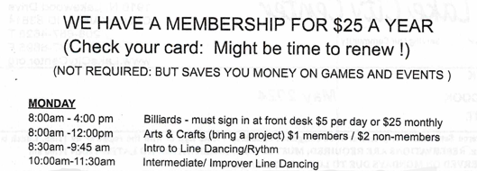

11

11